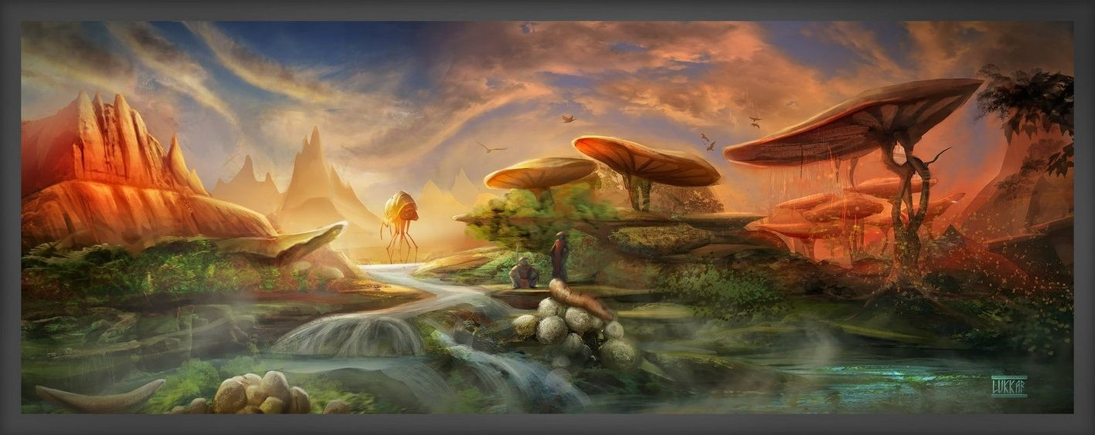

Skywind Application

TESRenewal Username: ​
rustydoormat

Country of Residence: Northern Ireland

Northern Ireland
Timezone: GMT0:00

Interested in:​
3D Modelling, Concept Art

Level of Commitment:

Student. weekend

Skills and Experience:​
3d modelling. organic and hard-surface. primarily I

use Maya, zbrush and marvelous. I texture using substance

painter/designer. experience in creating assets for unity. however I have

never used the creation kit.

Proof of Skill(s):​
https://dermottburns.artstation.com/

Proof of Skill(s):​
https://youtu.be/fFSQxb9IXHU

Proof of Skill(s):​
https://www.instagram.com/dermottanimation/

